
Name: | Riya Singh
Location: | Noida
Current Position: | Business Analyst
Experience: | Seasoned Business Analyst with 5+ years at Quotient Technology, skilled in project management & systems improvement. Expert in SQL, JIRA, Tableau, Adobe Campaign Tool. Proven in leading teams, analysing process & enhancing business outcomes. Committed to innovation & customer support through strategic planning and effective solutions. Good analytical, verbal, written communication, and interpersonal skills.
Certifications: | - Business Analysis Basic  - Agile Scrum Master  - Agile Scrum Foundation  - Tableau Training

TECHNICAL SKILLS

Skills | Business Analysis, Requirement Gathering, Agile Methodologies, BRD, FRD, User Stories, Use Cases, Scrum Event, Sprint Ceremonies, Adobe Campaign Tool Management • RDCM Project Management, Incident Management, Project Management
Tools & Technologies | Tableau, JIRA, SQL, Power Bi, Digital Marketing, Adobe Campaign Tool Management, Microsoft office
Methodologies | Agile/Scrum.

PROFESSIONAL EXPERIENCE

- QUOTIENT TECHNOLOGY INC. BUSINESS ANALYST- APRIL 2022-PRESENT

- Key Responsibilities:

- Translate business needs into comprehensive documentation, including requirements, specifications, and use cases, to guide software development processes effectively.

- Executed and analyzed digital coupon campaigns, utilizing SQL for database support, and enhancing decision-making.

- Managed project lifecycles with JIRA, and Power BI, streamlining processes and improving insights.

- Collaborated with Data Campaign Manager (DCM) on coupon strategies and Retail Digital Campaign Manager (RDCM) projects.

- Orchestrated Adobe Campaign platform advancements by working closely with stakeholders to assess requirements, translating them into technical blueprints, and configuring essential system elements such as campaign workflows and personalized content to elevate marketing operations and audience interaction.

- Demonstrated adaptability, effective communication, and problem-solving, using Microsoft PowerPoint and Excel for presentations and analysis.

PROFESSIONAL EXPERIENCE

LSEG (LONDON STOCK EXCHANGE GROUP) PROJECT ANALYST – MARCH 2019- MARCH 2022

- Key Responsibilities:

- Conducted market research to identify customer needs and preferences, guiding content creation strategies.

- Ensured business objectives aligned with content strategy through collaboration with internal stakeholders.

- Managed multiple projects, maintaining organization and meeting deadlines without sacrificing quality.

- Addressed client inquiries on US and Euro bonds, providing informed resolutions.

- Handled client queries and discrepancies related to internal products and Aladdin Security Master, ensuring data accuracy.

- Utilized Eikon and other tools for commodities content relevant to energy-efficient trading. • Implemented estimated resolution times for prompt and accurate client support.

PROJECTS
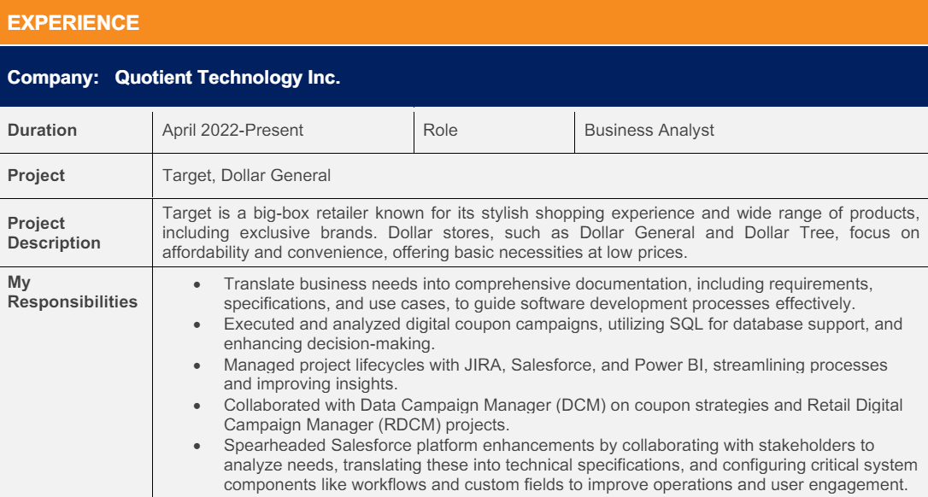

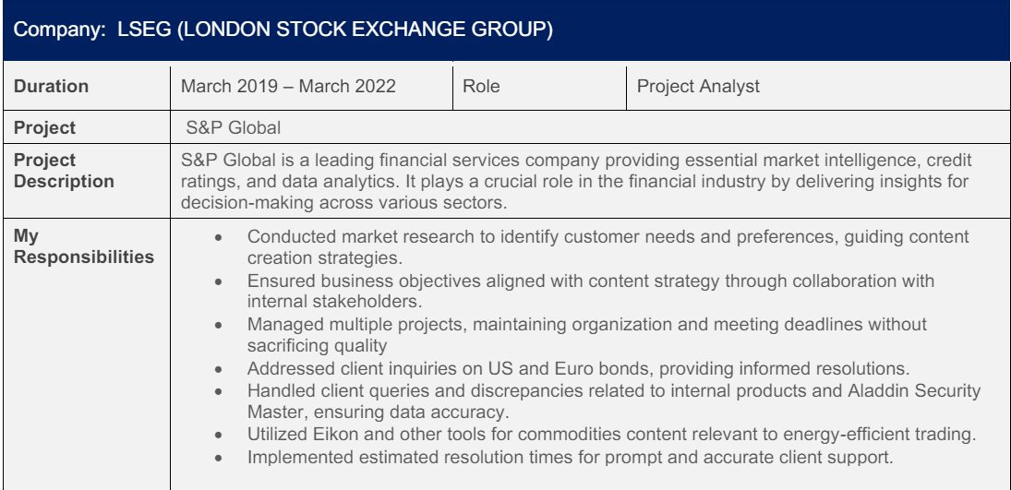
PREVIOUS PROFESSIONAL EXPERIENCE

QUOTIENT TECHNOLOGY INC.
BUSINESS ANALYST
APRIL 2022-PRESENT

LSEG (LONDON STOCK EXCHANGE GROUP)
PROJECT ANALYST
MARCH 2019- MARCH 2022

